|  |
| --- |
|  |
| Rectangle Calculator |
|  |
| Cert IV Programming |

**Sagun Shrestha**

December 17, 2016

Contents

Introduction: 2

Target Audience: 2

Purpose: 2

Initial Screen shot: 4

Final Screen shot: 5

Conclusion: 6

References: 6

# Introduction:

This is a program developed using android programming (Java and XML) to demonstrate the concept of building a simple Android application. It is developed using Android Studio as part of an assessment project for Certificate in Programming IV course. It is developed as a mobile application which focuses on working with Java and XML. This project also demonstrates the use of various features that are available in the Android Studio environment.

This program takes input from the user for the height and width of the rectangle. The numbers can be floating point numbers or whole numbers which are then used to calculate the area and the perimeter of the rectangle. The results are displayed to the user.

The calculator validates user input which can be only numbers and does not allow null values. Upon entering proper values for height and width, the application calculates and displays the area and perimeter of the rectangle in their proper placeholders. Overall, it is a simple and fun program developed to demonstrate the use of textview, edittext, classes, if-else statements and the use of functions and subs.

# Target Audience:

This is a simple program designed to demonstrate the concept of android programming. It focuses on beginners learning how to program using android studio environment. This project deals with buttons, textview, edittext as user interface which interacts with java file named MainActivity.java at the backend. The user interface is designed using drag n drop features and contained within an XML file. It also identifies the difference between portrait and landscape position and provides different XML files for each to ensure consistency and uniformity. The onClick event triggers the logic at the backend which performs the necessary calculations and displays result to the user. So, this project is mainly targeted to those who wants to learn programming using android studio and develop mobile applications.

# Purpose:

The purpose of this project is to demonstrate the understandability of java programming language and the use of Android Studio environment for developing a mobile application. This project mainly deals with textview, edittext, button, class and user validation techniques. It requires reading data from user and verifying it before using the data. It shows how methods are triggered using buttons as input from user. The completion of this project allowed me to understand how to think and plan ahead before you start the project. It helped me to understand the flow of program logic and how the use of functions and subs break down the code into smaller manageable chunks which can be easily understood and reused.

List of Main Subs and Functions used in the program are listed below:

onCreate():

onCreate is used to start an activity. User Interface is also loaded from the XML file and OnClickListener is set for button click event.

onClick():

This method is called upon the click event of the calculate button. The majority of calculation happens in this sub-routine. Textviews and edittexts are defined, validation is done, data is taken from user and performed necessary calcuations and returned result to the user via textviews.

Clear():

This method clears all the values from textview and edittext fields from the user interface.

Program Guide:

1. Start the Calculator application.
2. Enter any numeric value for height.
3. Enter any numeric value for width.
4. Press ‘Calculate’ button to display the ‘area’ and ‘perimeter’ of rectangle.
5. Press ‘Reset’ button to clear all the fields.
6. Close the application.

# Initial Screen shot:

# 

# Final Screen shot:

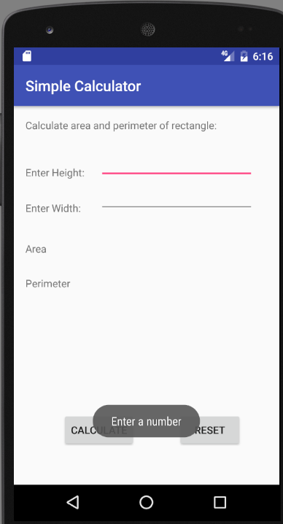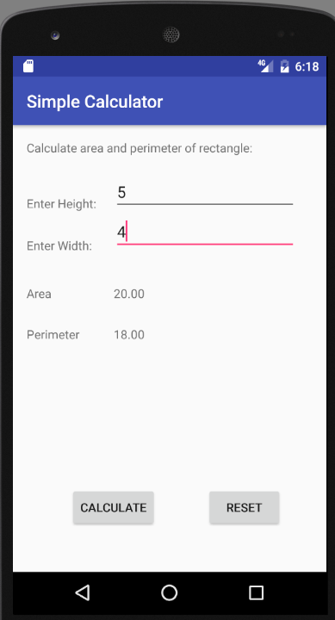

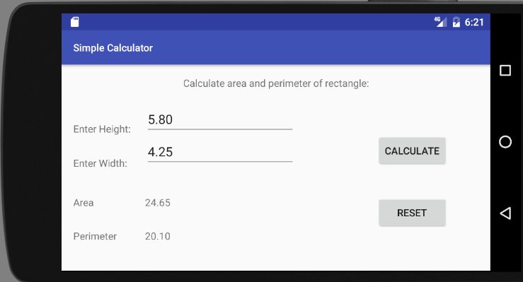

# Conclusion:

The completion of this project helped me to understand how to work Android Studio environment to develop a simple rectangle calculator application. This project helped me to identify the project requirements and find a systematic methodology to achieve the goal. I was able to implement onclick method which gets executed during the click event and performs necessary calculations. I learned how to manipulate XML files to design user interface and separate program logic inside the java file. Moreover, I learned how to manage program flow and validate user data with the use of loops to accomplish the project goal. The Android studio environment made it so much easier to write and edit codes. It made finding and fixing errors using the debug mode a lot easier and less troublesome.

# References:

* [www.stackoverflow.com](http://www.stackoverflow.com)